My Learning Plan Login and Registration
- Log in with your email address and password = nvcsreg
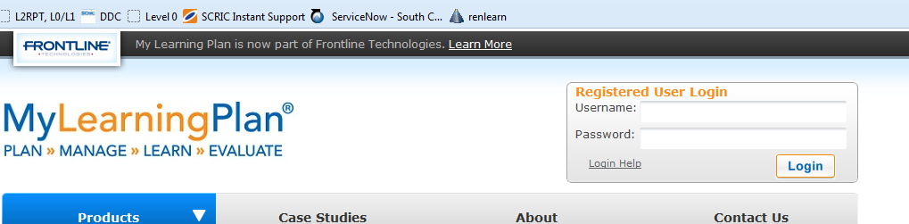

- Click on BT BOCES Catalog
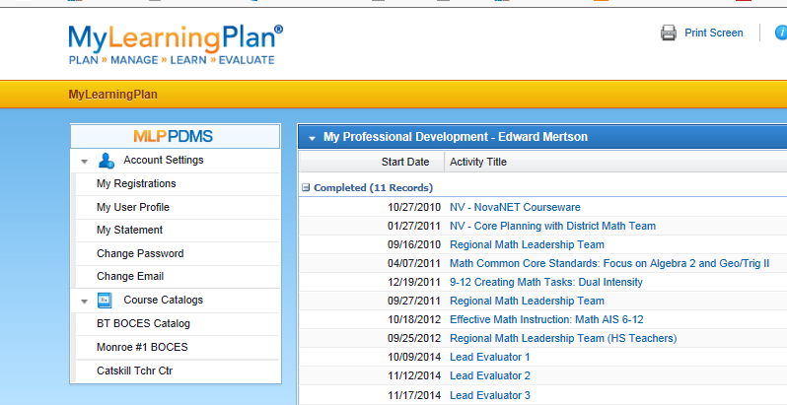

- Use the search box to find your course.
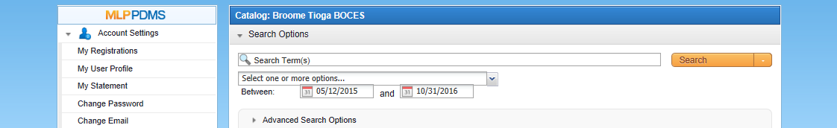

- Select your course and click the Enroll button at the bottom of the page.

- Fill in any necessary information and submit your enrollment.

- Return to the home screen and you should see your course under “Pending”
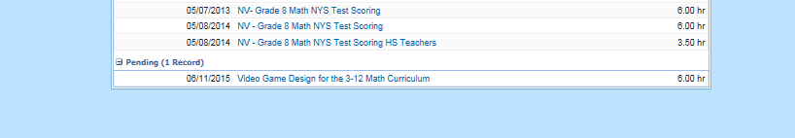
- Select your course, and scroll to the bottom where you will see 5 buttons. Select
“Print Enrollment Form”
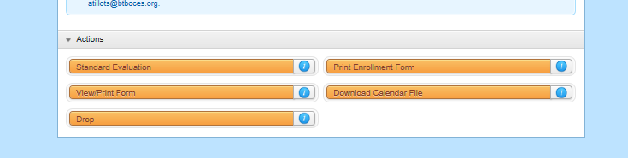
- View and print the Enrollment Form.
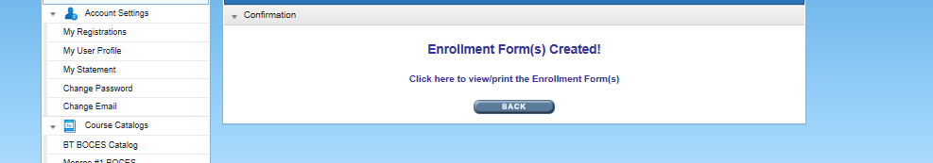

- You should have a form that looks like this. Submit the form to the Principal, then send the form to the District Office for District Approval and BOCES Registration.
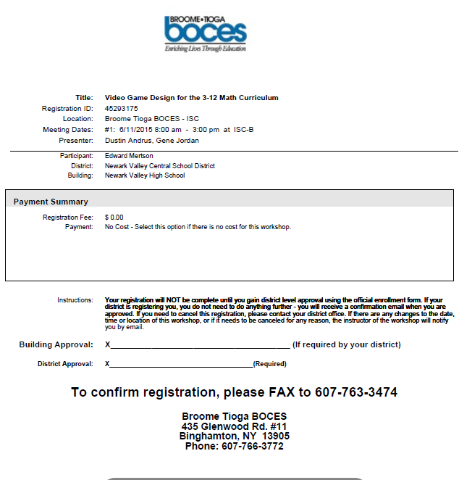

- After the Superintendent approves the request, I’ll fax it to BOCES, and send you a copy.

